*from* datetime *import* datetime

*import* json

*import* sys

*from* PyQt5.QtCore *import* *

*from* PyQt5.QtWebEngineWidgets *import* *

*from* PyQt5.QtWidgets *import* QApplication

dob = datetime.now().strftime(('%d-%m'))

print(dob)

class crawler:

    def __init__(*self*) -> None:

        *# updates the date of borth according to the date/ Internal Server where data is manually stored by the user*

        mydata = {

            "User1":{"Name": "Abi", "DOB": "01-04", "Number" :""},

            "User2":{"Name": "soniya", "DOB" : "12-04", "Number" :""},

            "User3":{"Name": "Radhika", "DOB": "15-05", "Number" :""},

            "User4":{"Name": "santosh", "DOB": "23-09", "Number" :""},

            "User5":{"Name": "chinna swami", "DOB" : "15-05","Number" :""},

            "User6":{"Name": "Laxmi Shreya", "DOB" : dob,"Number" :""},

            "User7":{"Name": "Vidya", "DOB": "15-05","Number" :""},

            "User8":{"Name": "preethi", "DOB": "07-05","Number" :""},

            "User9":{"Name": "Mohini Junior", "DOB" : "15-05","Number" :""},

            "User10":{"Name": "Latha K", "DOB" : dob,"Number" :""},

            "User11":{"Name": "Hema", "DOB" : "01-07","Number" :""},

            "User12":{"Name": "Malini", "DOB" : "03-10","Number" :""},

"User13":{"Name": "Raani", "DOB" : "15-05","Number" :""},

            "User14":{"Name": "Aamir", "DOB" : "12-04","Number" :""},

            "User15":{"Name": "meher", "DOB" : "15-02","Number" :""},

            "User16":{"Name": "sneha", "DOB": "01-04","Number" :""},

            "User17":{"Name": "Nupur", "DOB": "10-02","Number" :""},

            "User18":{"Name": "sangeetha", "DOB" : "01-04","Number" :""},

            "User19":{"Name": "Sahana", "DOB" : "10-02","Number" :""},

            "User20":{"Name": "Anurag", "DOB" : "15-06","Number" :""},

            "User21":{"Name": "vamshi", "DOB" : "19-02","Number" :""},

            "User22":{"Name": "Mayur", "DOB": "10-02","Number" :""},

            "User23":{"Name": "Naveen Singh", "DOB": "10-11","Number" :""},

            "User24":{"Name": "Meghana", "DOB": "13-09","Number" :""},

            "User25":{"Name": "Bindu", "DOB": dob, "Number" :""},

            "User26":{"Name": "Raani", "DOB" : dob, "Number" :"5367"}

        }

*# The Birthdays data is saved onto Json file*

        *with* open("data.json", "w") *as* outfile:

            json.dump(mydata, outfile,*indent*=4)

        print("Birthday list updated into the file named data\n")

        crawl_data = *self*.birthday()

    def birthday(*self*):

*# stored html code into index.text and helps to match the names with the website*

        f = open('index.txt', 'r', *encoding*='cp850').read()

*# converts string into html*

        *# data = html.fromstring(f)*

*# # extraction of names*

*# name = data.xpath('//div[@class="item-1  flex-grow-2 middle"]/h5/text()')*

*# reading json data to map with the birthdays*

        json_data = open('data.json')

*# loads the json data into a variable*

        data = json.load(json_data)

        *# checks whether the date of birth matching todays date, if matches then send the the message to the respective individual*

*for* i *in* data:

*# print(type(data[i]["DOB"]))*

*if* dob == data[i]["DOB"]:

*self*.message(i)

def message(*self*,*i*):

        print("Birthday wishes has been shared to:", *i*)

crawler()

app = QApplication(sys.argv)

web = QWebEngineView()

web.load(QUrl("http://127.0.0.1:5500/index.html"))

web.show()

sys.exit(app.exec_())

**TESTING:**

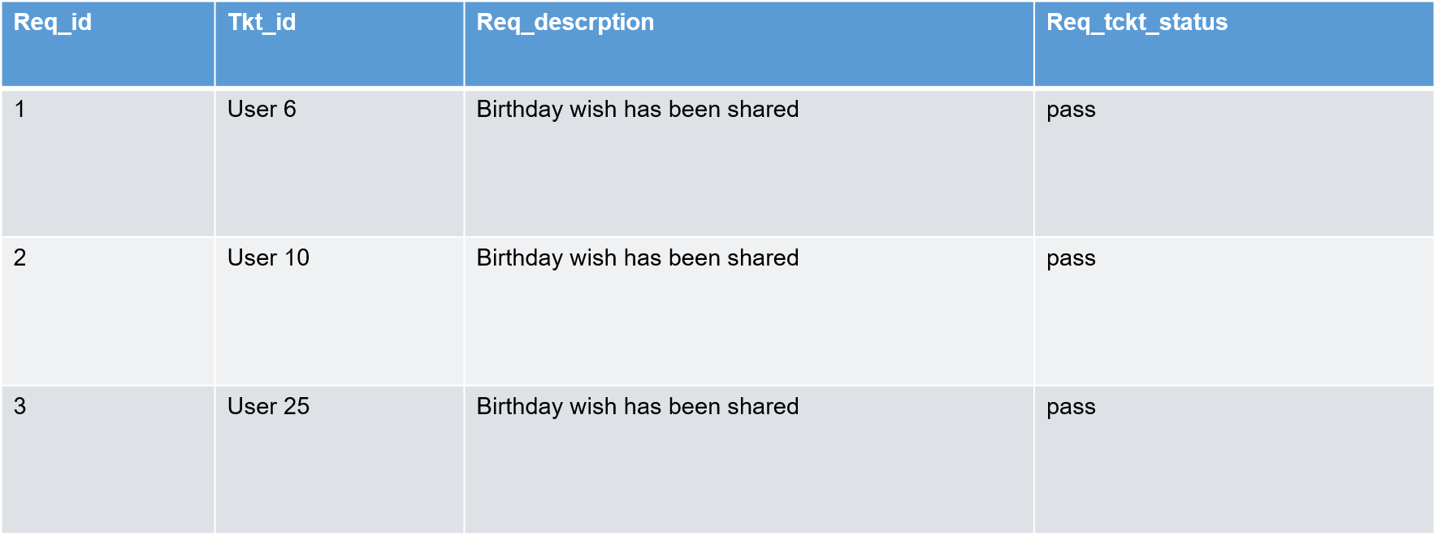

**OUTPUTS:**

